**GET READY….HE’S COMIN’!!**

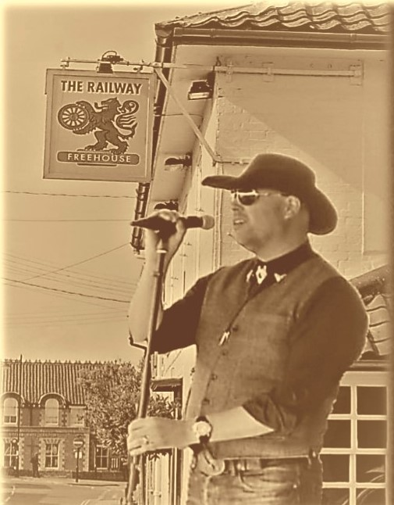

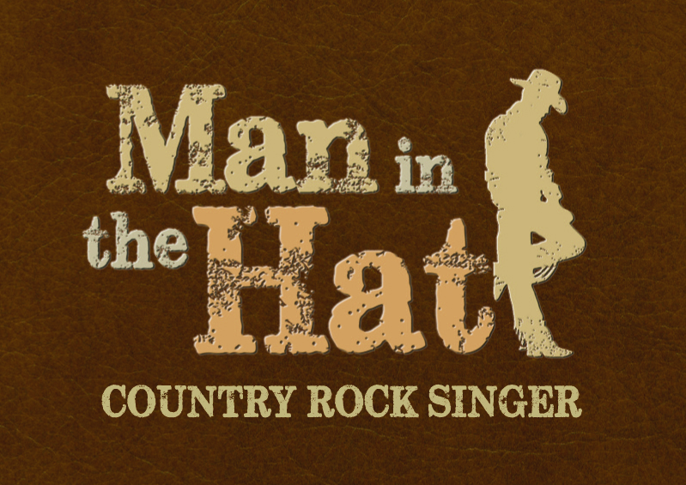

**POST- LOCKDOWN HOEDOWN**

**In The garden of**

**The Railway Inn - Framlingham**

**Saturday 1st May 7:30pm –late**

**Tickets available from RAILWAY TICKET LINE 01728 724760**

**From 12noon- Monday 12th April – £5 per head**

**Tables of up to 6 people - First come first served!**

**from Midday Thursday 6th August – First come first served!**

**Also Streaming live on FACEBOOK**

[**www.maninthehatmusic.co.uk**](http://www.maninthehatmusic.co.uk) **07884 243539**

**www.facebook.com/ManintheHatCountryRock**

**www.soundcloud.com/maninthehatmusic**

## Including songs by Country and Country-Rock artists such as:

## Kenny Rogers, Garth Brooks, Eagles, Don Mclean Toby Keith, Lonestar,

## John Denver, Travis Tritt, The Mavericks, Willie Nelson, Tim McGraw, Credence Clearwater Revival, Johnny Cash, Blake Shelton, Smokie,

## Billy Ray Cyrus, Bob Segar, Bellamy Brothers, Elvis Presley, Bob Dylan, Neil Diamond, Darius Rucker, Glen Campbell & Travelling Willburys